Name : Yedatkar Mohan Lobhaji Sub : Sem-II

Roll N0 : 271 Practical : 01

**Aim :** Design an html form for displaying information using interactive css including images, tables.

**CODE:**

<!DOCTYPE html>

<html lang="en">

<head>

  <meta charset="UTF-8" />

  <meta name="viewport" content="width=device-width, initial-scale=1.0" />

  <title>My College Info</title>

 <style>

    /* Reset default styles */

* {

  margin: 0;

  padding: 0;

  box-sizing: border-box;

}

body {

  font-family: 'Segoe UI', sans-serif;

  background-color: #f4f7fc;

  color: #333;

  padding: 20px;

}

.container {

  max-width: 1000px;

  margin: auto;

  background: white;

  padding: 30px;

  border-radius: 15px;

  box-shadow: 0 10px 30px rgba(0, 0, 0, 0.1);

}

header {

  text-align: center;

  margin-bottom: 30px;

}

.banner {

  width: 100%;

  height: auto;

  border-radius: 10px;

  margin-bottom: 15px;

}

h1 {

  color: #2c3e50;

  font-size: 2.2rem;

}

section {

  margin-bottom: 40px;

}

h2 {

  font-size: 1.5rem;

  color: #34495e;

  margin-bottom: 10px;

}

.about p {

  line-height: 1.7;

  font-size: 1rem;

}

table {

  width: 100%;

  border-collapse: collapse;

  margin-top: 15px;

}

th, td {

  padding: 12px;

  text-align: left;

  border-bottom: 1px solid #ddd;

}

th {

  background-color: #3498db;

  color: white;

}

td {

  background-color: #ecf6fd;

}

.image-grid {

  display: grid;

  grid-template-columns: repeat(auto-fit, minmax(250px, 1fr));

  gap: 15px;

}

.image-grid img {

  width: 100%;

  height: auto;

  border-radius: 10px;

  transition: transform 0.3s ease, box-shadow 0.3s ease;

}

.image-grid img:hover {

  transform: scale(1.05);

  box-shadow: 0 10px 20px rgba(0, 0, 0, 0.2);

}

 </style>

</head>

<body>

  <div class="container">

    <header>

      <img src="https://mgmcen.ac.in/images/slide4.jpg" alt="College Banner" class="banner" />

      <h1>MGM College of Engineering, Nanded</h1>

    </header>

    <section class="about">

      <h2>About Us</h2>

      <p>

        MGM College of Engineering, Nanded offers top-quality technical education and has state-of-the-art infrastructure, expert faculty, and a vibrant student community.

      </p>

    </section>

    <section class="info-table">

      <h2>College Details</h2>

      <table>

        <tr>

          <th>Established</th>

          <td>1984</td>

        </tr>

        <tr>

          <th>Affiliation</th>

          <td>Dr.Babasaheb Ambedkar Technological University</td>

        </tr>

        <tr>

          <th>Courses Offered</th>

          <td>BCA,BSE,B.Tech, M.Tech,</td>

        </tr>

        <tr>

          <th>Location</th>

          <td>Nanded, Maharashtra</td>

        </tr>

      </table>

    </section>

    <section class="gallery">

      <h2>Gallery</h2>

      <div class="image-grid">

        <img src="https://mgmcen.ac.in/images/gallery/19102016163702-Inner-Courtyard.jpg" alt="Campus View" />

        <img src="https://mgmcen.ac.in/images/gallery/Lab%20Inauguration-20132812150304.jpg" alt="Computer Lab" />

        <img src="https://mgmcen.ac.in/images/Jhankaar/j8.jpg" alt="College Event" />

      </div>

    </section>

  </div>

</body>

</html>

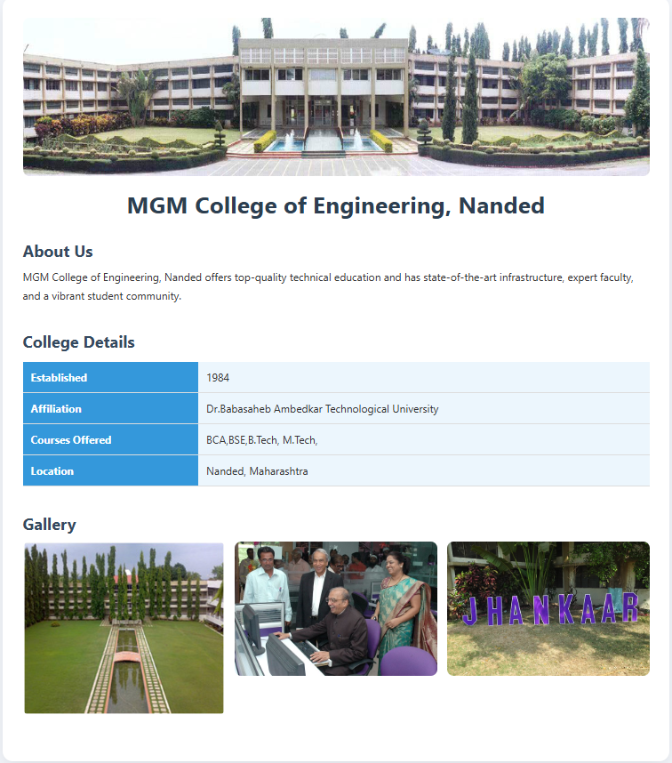**OUTPUT:**